Profile: China
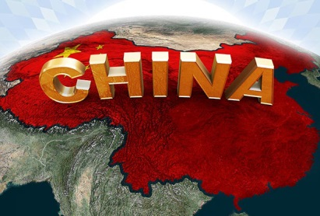

This is a profile of China. It is the richest country in the region of Asia. The GDP of China is approximately 9.24 trillion dollars per year.

Exports | %
Electronic equipment | 24.4%
Machines | 17.1%
Furniture, lighting | 4.0%
Knit or crochet clothing | 3.9%
Clothing | (3.5%

Regional Economies
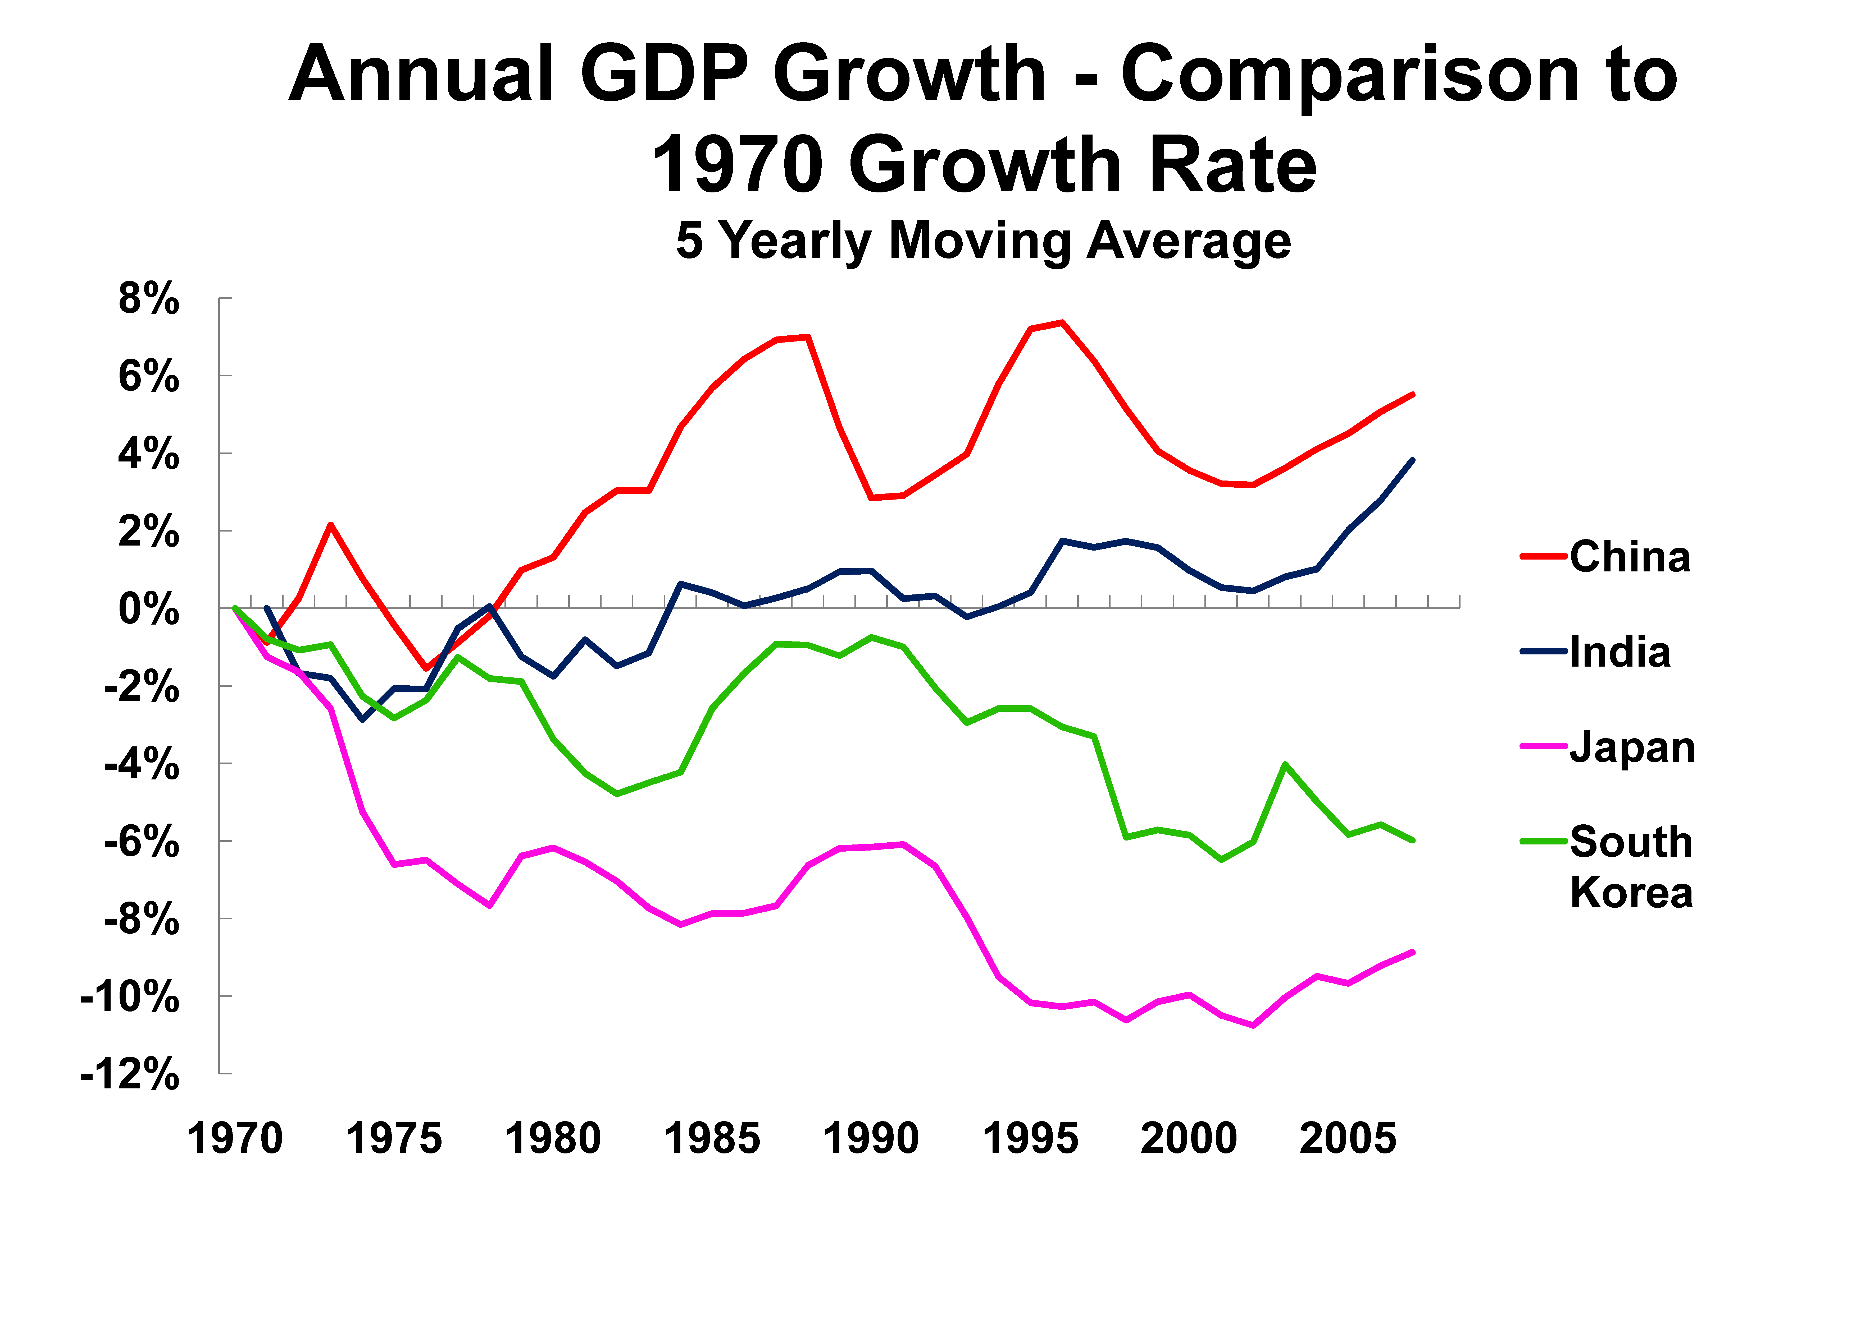
Country | GDP | Main Exports
China | 9.24 trillion | Electronic equipment
Japan | 4.92 trillion | Electronic equipment
India | 1.877 trillion | Nickel
South Korea | 1.305 trillion | Vehicles

The regional economy is strong. The region is dominated by China. However, the other countries in the region are strong. South Korea is behind the other countries in exports and GDP.

